Poker – Lab #3

Clone & Disconnect the starter project:

<https://github.com/CISC181/Lab3Starter>

Poker is a great game to teach object oriented concepts!

The game of poker is relatively simple. In the standard version of the game (5 card stud), 5 cards are dealt to 2 or more players. The cards that are dealt to a player is known as a “hand”. Each hand is evaluated/scored, and then compared with the other player’s hands to find the winner.

In traditional poker, a hand could be one of 10 different categories. The odds of drawing each hand depends on the combination of cards, frequency, etc. The probability can be calculated with as a simple combination. The table below shows the ten different categories, probability and cumulative probability:

|  |  |  |  |  |  |
| --- | --- | --- | --- | --- | --- |
| **Hand** | **Distinct Hands** | **Freq** | **Probability** | **Cumulative probability** | **Odds** |
| [Royal flush](http://en.wikipedia.org/wiki/Hand_rankings#Straight_flush)  [10 of spades](http://en.wikipedia.org/wiki/File:Playing_card_spade_10.svg)[Jack of spades](http://en.wikipedia.org/wiki/File:Playing_card_spade_J.svg)[Queen of spades](http://en.wikipedia.org/wiki/File:Playing_card_spade_Q.svg)[King of spades](http://en.wikipedia.org/wiki/File:Playing_card_spade_K.svg)[Ace of spades](http://en.wikipedia.org/wiki/File:Playing_card_spade_A.svg) | 1 | 4 | 0.000154% | 0.000154% | 649,739 : 1 |
| [Straight flush](http://en.wikipedia.org/wiki/Hand_rankings#Straight_flush) (excluding royal flush)  [4 of hearts](http://en.wikipedia.org/wiki/File:Playing_card_heart_4.svg)[5 of hearts](http://en.wikipedia.org/wiki/File:Playing_card_heart_5.svg)[6 of hearts](http://en.wikipedia.org/wiki/File:Playing_card_heart_6.svg)[7 of hearts](http://en.wikipedia.org/wiki/File:Playing_card_heart_7.svg)[8 of hearts](http://en.wikipedia.org/wiki/File:Playing_card_heart_8.svg) | 9 | 36 | 0.00139% | 0.00154% | 72,192 : 1 |
| [Four of a kind](http://en.wikipedia.org/wiki/Hand_rankings#Four_of_a_kind)  [Ace of hearts](http://en.wikipedia.org/wiki/File:Playing_card_heart_A.svg)[Ace of diamonds](http://en.wikipedia.org/wiki/File:Playing_card_diamond_A.svg)[Ace of clubs](http://en.wikipedia.org/wiki/File:Playing_card_club_A.svg)[Ace of spades](http://en.wikipedia.org/wiki/File:Playing_card_spade_A.svg)[4 of diamonds](http://en.wikipedia.org/wiki/File:Playing_card_diamond_4.svg) | 156 | 624 | 0.0240% | 0.0256% | 4,164 : 1 |
| [Full house](http://en.wikipedia.org/wiki/Hand_rankings#Full_house)  [8 of hearts](http://en.wikipedia.org/wiki/File:Playing_card_heart_8.svg)[8 of diamonds](http://en.wikipedia.org/wiki/File:Playing_card_diamond_8.svg)[8 of clubs](http://en.wikipedia.org/wiki/File:Playing_card_club_8.svg)[King of hearts](http://en.wikipedia.org/wiki/File:Playing_card_heart_K.svg)[King of spades](http://en.wikipedia.org/wiki/File:Playing_card_spade_K.svg) | 156 | 3,744 | 0.144% | 0.17% | 693 : 1 |
| [Flush](http://en.wikipedia.org/wiki/Hand_rankings#Flush) (excluding royal flush and straight flush)  [10 of clubs](http://en.wikipedia.org/wiki/File:Playing_card_club_10.svg)[4 of clubs](http://en.wikipedia.org/wiki/File:Playing_card_club_4.svg)[Queen of clubs](http://en.wikipedia.org/wiki/File:Playing_card_club_Q.svg)[7 of clubs](http://en.wikipedia.org/wiki/File:Playing_card_club_7.svg)[2 of clubs](http://en.wikipedia.org/wiki/File:Playing_card_club_2.svg) | 1,277 | 5,108 | 0.197% | 0.367% | 508 : 1 |
| [Straight](http://en.wikipedia.org/wiki/Hand_rankings#Straight) (excluding royal flush and straight flush)  [7 of clubs](http://en.wikipedia.org/wiki/File:Playing_card_club_7.svg)[8 of hearts](http://en.wikipedia.org/wiki/File:Playing_card_heart_8.svg)[9 of diamonds](http://en.wikipedia.org/wiki/File:Playing_card_diamond_9.svg)[10 of hearts](http://en.wikipedia.org/wiki/File:Playing_card_heart_10.svg)[Jack of spades](http://en.wikipedia.org/wiki/File:Playing_card_spade_J.svg) | 10 | 10,200 | 0.392% | 0.76% | 254 : 1 |
| [Three of a kind](http://en.wikipedia.org/wiki/Hand_rankings#Three_of_a_kind)  [Queen of hearts](http://en.wikipedia.org/wiki/File:Playing_card_heart_Q.svg)[Queen of clubs](http://en.wikipedia.org/wiki/File:Playing_card_club_Q.svg)[Queen of diamonds](http://en.wikipedia.org/wiki/File:Playing_card_diamond_Q.svg)[5 of spades](http://en.wikipedia.org/wiki/File:Playing_card_spade_5.svg)[Ace of diamonds](http://en.wikipedia.org/wiki/File:Playing_card_diamond_A.svg) | 858 | 54,912 | 2.11% | 2.87% | 46.3 : 1 |
| [Two pair](http://en.wikipedia.org/wiki/Hand_rankings#Two_pair)  [3 of hearts](http://en.wikipedia.org/wiki/File:Playing_card_heart_3.svg)[3 of diamonds](http://en.wikipedia.org/wiki/File:Playing_card_diamond_3.svg)[6 of clubs](http://en.wikipedia.org/wiki/File:Playing_card_club_6.svg)[6 of hearts](http://en.wikipedia.org/wiki/File:Playing_card_heart_6.svg)[King of spades](http://en.wikipedia.org/wiki/File:Playing_card_spade_K.svg) | 858 | 123,552 | 4.75% | 7.62% | 20.0 : 1 |
| [One pair](http://en.wikipedia.org/wiki/Hand_rankings#One_pair)  [5 of hearts](http://en.wikipedia.org/wiki/File:Playing_card_heart_5.svg)[5 of spades](http://en.wikipedia.org/wiki/File:Playing_card_spade_5.svg)[2 of clubs](http://en.wikipedia.org/wiki/File:Playing_card_club_2.svg)[Jack of clubs](http://en.wikipedia.org/wiki/File:Playing_card_club_J.svg)[Ace of diamonds](http://en.wikipedia.org/wiki/File:Playing_card_diamond_A.svg) | 2,860 | 1,098,240 | 42.3% | 49.9% | 1.36 : 1 |
| [No pair](http://en.wikipedia.org/wiki/Hand_rankings#High_card) / High card  [2 of diamonds](http://en.wikipedia.org/wiki/File:Playing_card_diamond_2.svg)[5 of spades](http://en.wikipedia.org/wiki/File:Playing_card_spade_5.svg)[6 of spades](http://en.wikipedia.org/wiki/File:Playing_card_spade_6.svg)[Jack of hearts](http://en.wikipedia.org/wiki/File:Playing_card_heart_J.svg)[Ace of clubs](http://en.wikipedia.org/wiki/File:Playing_card_club_A.svg) | 1,277 | 1,302,540 | 50.1% | 100% | 0.995 : 1 |
| **Total** | **7,462** | **2,598,960** | **100%** | **---** | **1 : 1** |

Let’s think of the game in terms of objects, let’s start at the lowest level…

A “card” is an object.

* Each card has a numeric rank (A, 2, 3, 4.. 10, J, Q, K, A)
* Each card has a suit (heart, spade, club diamond)
* Attributes should be private, without public setter / getters

A “deck” is an object.

* Each deck (you could have multiple decks, depending on the game) is an array of cards.
* When you instantiate a deck, you should build the array list of cards. You should also “shuffle” the deck (make the order of cards random).
* A method is needed that will be to “draw” from the deck (return next card… assuming deck is shuffled).
* Build a method to denote how many cards are remaining to be drawn.

A “handpoker” is an object.

* Each hand is an array of cards that are drawn from the deck.
* A common (static) method is needed to judge a single hand. A similar method (overloaded) will be needed to judge multiple hands (you pass in array of hands, it passes back the winner).

The following class diagram isn’t perfect, but is a good starting point:

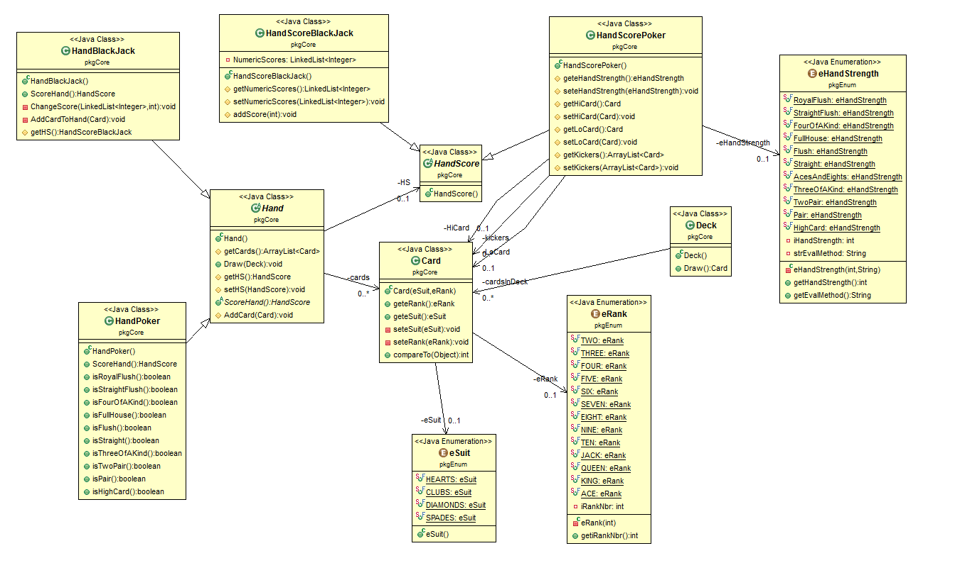

Deliverables for Lab #2:

* Start by using the starter project. I gave you the class name and the ‘imports’ statement, you need to do the rest
* Card – This class is in pretty good shape. Read the code, get familiar with the class.
* Deck – Not much has changed since Blackjack. Should be no changes in this class
* HandPoker
  + Implement each of the //TODO methods. Use IsFullHouse() as a template.
* HandScorePoker – This class is in good shape.
* Junit tests
  + Should be a test for each kind of hand, and each combination of hand. Example, should have two ‘four-of-a-kind’ tests (K-K-K-K-A, J-Q-Q-Q-Q).

Future labs…

* Handle ‘wild’ card. The ability to turn on/off given card(s) as ‘wild’. Wild card can be substituted for any other card during hand evaluation.
* Building an JavaFX, Android GUI (graphical user interface)
* Add new games (5 card draw, 7 card draw, Texas Hold ‘em).
* Trials to make sure program is dealing / randomizing correctly.

Grading – general guidelines/rubric

|  |  |  |  |
| --- | --- | --- | --- |
|  | **Exemplary** | **Developing** | **Oh, come on!** |
| **Timeliness**  (25%) | Completed on time.  25 points | More than 1 day, less than one week late.  10 points. | More than 1 week late, less than 2 weeks late.  More than 2 weeks late – no submission possible.  0 points |
| **Knowledge of Content**  (40%) | Lab completed the bulleted deliverables, all functionality implemented, program(s) works as it should  40 points | Missed one deliverable  Example:   * Used JDK 1.7 instead of JDK 1.8 * Missed JUnit test case(s)   20-35 points | Missed more than one deliverable  0 – 20 points |
| **Coding- Design or Runtime errors**  (35%) | No errors, program compiles and executes as expected  35 points | No more than two errors  20-35 points | More than two errors  0-20 points |